|  |
| --- |
| **Student Startup Registration**    **A PROJECT REPORT**  **Submitted by**  **BJS Team**  *of*  **Bachelor In Computer Application**  **Bhartiya Jain Sanghatana’s**  **Arts, Science & Commerce College**  **Pune University**  **December 2022** |

1. **ACKNOWLEDGEMENT**

I would like to express my special thanks to our project guide Prakash Sharma Sir who gave me the golden opportunity to do this wonderful project on the topic **Student Startup Registration**, which also helped us in doing a lot of research and we came to know about so many new things. We are really thankful to them.

Secondly I would also like to thank our teachers and project members who helped us a lot in this project.

|  |  |  |  |
| --- | --- | --- | --- |
| **Sr.No** | **NAME OF STUDENT** | **CLASS** | **EMAIL ID** |
| 1 | Sujit Kargal | SYBCA | sujitkargal0@gmail.com |
| 2 | Pranil Takawane | SYBCA | takawanepranil22@gmail.com |
| 3 | Pratiksha Pare | TYBCA | pratiksha17pare@gmail.com |
| 4 | Pritam Pokale | TYBCA | pokalepritam@gmail.com |
| 5 | Nandini Shelar | TYBCA | nandinishelar2002@gmail.com |
| 6 | Rahul Nandanwar | TYBCA | rahulsnandanwar21@gmail.com |

|  |  |  |
| --- | --- | --- |
| Date : |  |  |
| Place : |  |  |
|  |  |  |

1. **INTRODUCTION**

In this project we are developing a student startup Registration form and also we are providing this form with a good and clean user experience . with the help of this form, users can fill their information easily. We provide their total 19 fields in their 14 fields for project details and other 5 for student details. In their startup name, student name, college name, Email, phone, team size for project, Prototype, technology, skills, hobbies, painpoint and user can upload their team photo And ppt of project demo .

For the front-end we use HTML5 , CSS3, Bootstrap5 and JavaScript. We also insert their logos of PCOMBINATOR , PASSION IT and there is also a button for submit the data Whenever data Will be submitted it Store in our database we are using mysql database for storing data. in there we make one database which is **startup_spinoff** and in that database we make two tables one for Startup Infomation and another is for Team information.

In there we use a primary key of the first table as a foreign key in the second table. In their we are doing many operations After Form Submitted Then User can fetch data from database and he can directly delete it or update it for this purpose we are provided buttons in their

For the backend we use different languages like Java, PHP, JavaScript and Mysql for inserting the data in the database. We use Java and PHP for CRUD Operation’s and also connect the database to HTML/JSP pages. We run this project on a web browser.

**3. METHODOLOGY**

* For this form development we firstly see the lot of form types then we draw the flowchart of this form process.
* We make this form in html5 and use css for styling.
* We choose the Language’s and best Editor’s for coding.
* In there we use many languages like HTML5, CSS3, Java, JavaScript and PHP.

Table 3.1 :language and their use

|  |  |  |
| --- | --- | --- |
| **Sr.No** | **Name Of Language** | **Use** |
| 1 | HTML5 | For the structure of form |
| 2 | CSS3 | For the style |
| 3 | JAVA,Servlet,JSP | For back-end / crud operation |
| 4 | PHP | For back-end / crud operation / connect form with Database |
| 5 | JavaScript | For scripting |
| 6 | MYSQL | For Database |

**4. OPERATIONS**

**4.1 Submit Button :**

In this form we put a **Submit Button** whenever the user fills the data and click submit button the data will be stored in the database if there remains an empty field which is mandatory then data will not submit.

Diagram 4.1.1

|  |
| --- |
| Start  Insert the information  Check the fill fields are empty or wrong  If empty or wrong ?  Information store in DB  DB  End  No  Yes |

**4.2 Clear Button:**

When the user clicks on the **Reset Button** the data will erase which are filled by user.

Diagram 4.2.1

|  |
| --- |
| Start  Click on Reset button  Fill Information Will Be Erase  End |

Flowchart of Reset button

**4.3 Update Button:**

User clicks on update button the data fetch from database

And Put On Form Field’s User Can Add And Delete Information . After All Done Submit Button Is Saved All Information To The Database.

And User Controlled Put On User To The View Page.

Diagram 4.3.1

|  |
| --- |
| Start  Click on update button  Show the details for update  If data  fetch from DB  Add again save in DB  End  Database  Yes  No |

Flowchart of Reset Button

**4.4 Delete Button :**

It is also for only the User can delete records from the database with the help of the primary key.

Diagram 4.3.1

|  |
| --- |
| Start  End  The record will be delete  Check primary key  Click on delete button  If primary key is present in DB  Yes  No |

Flowchart of delete button

**5. PICTURES**

5.1 Homepage

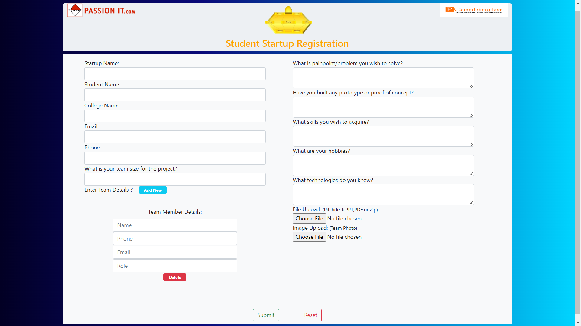

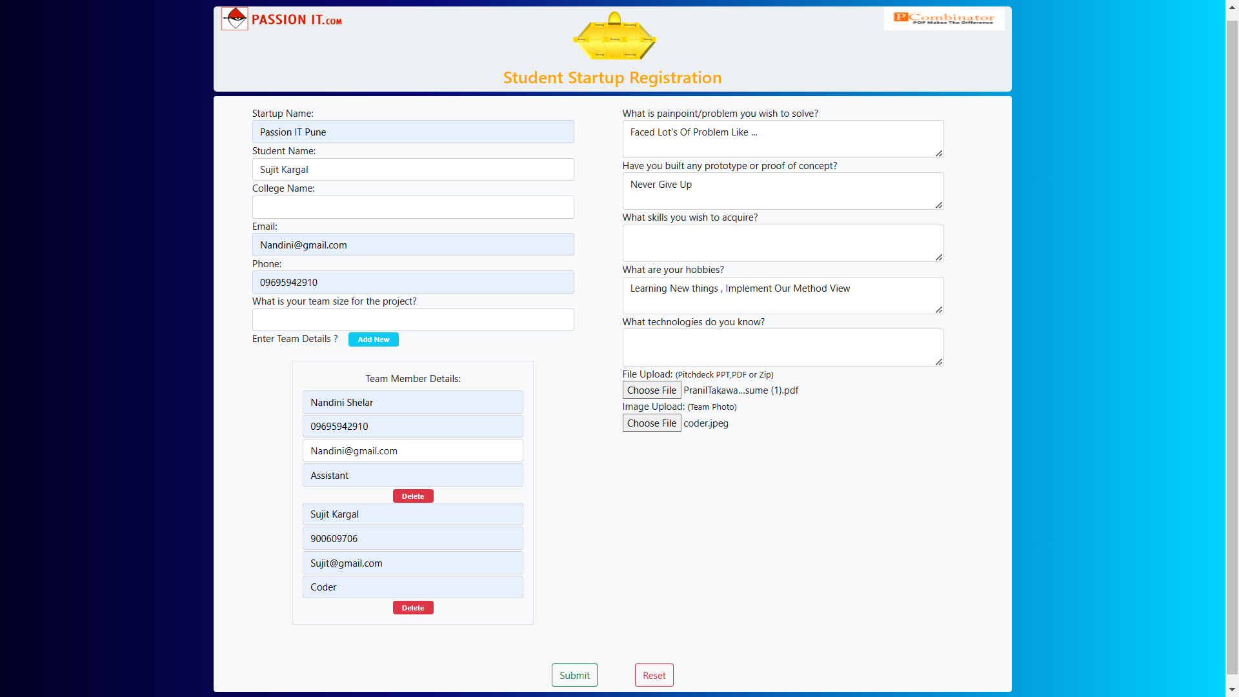

5.2 Data fetch from Database

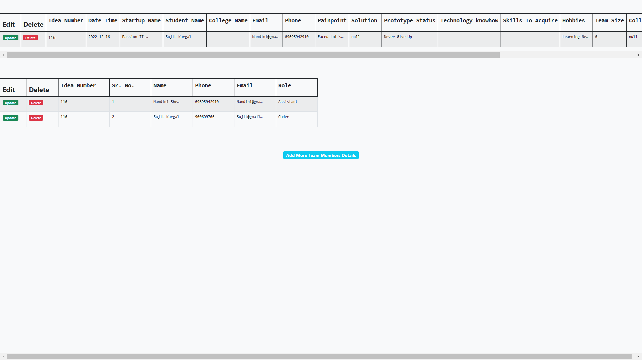

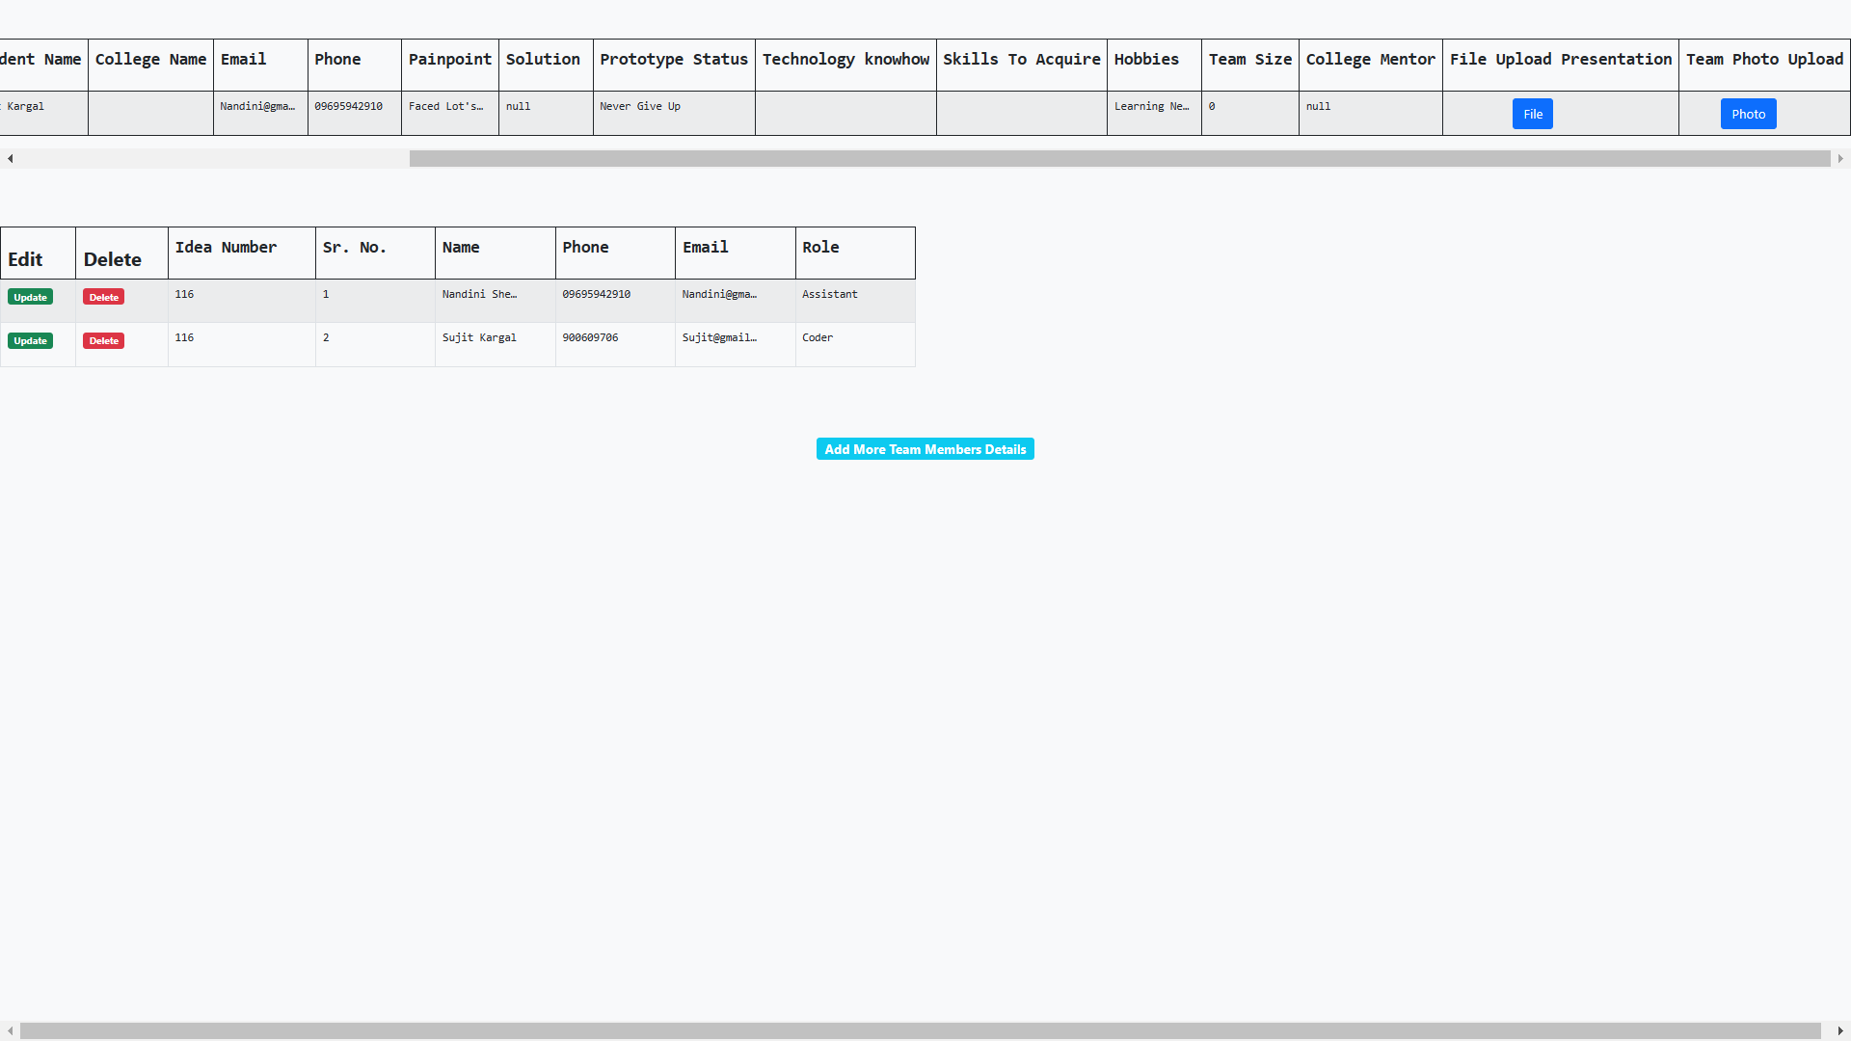

5.3 Update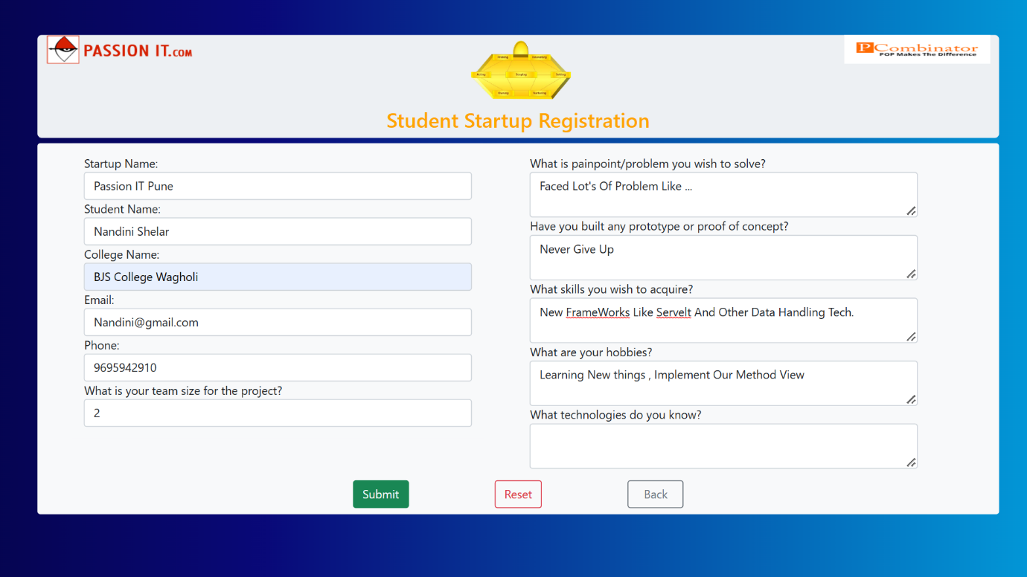

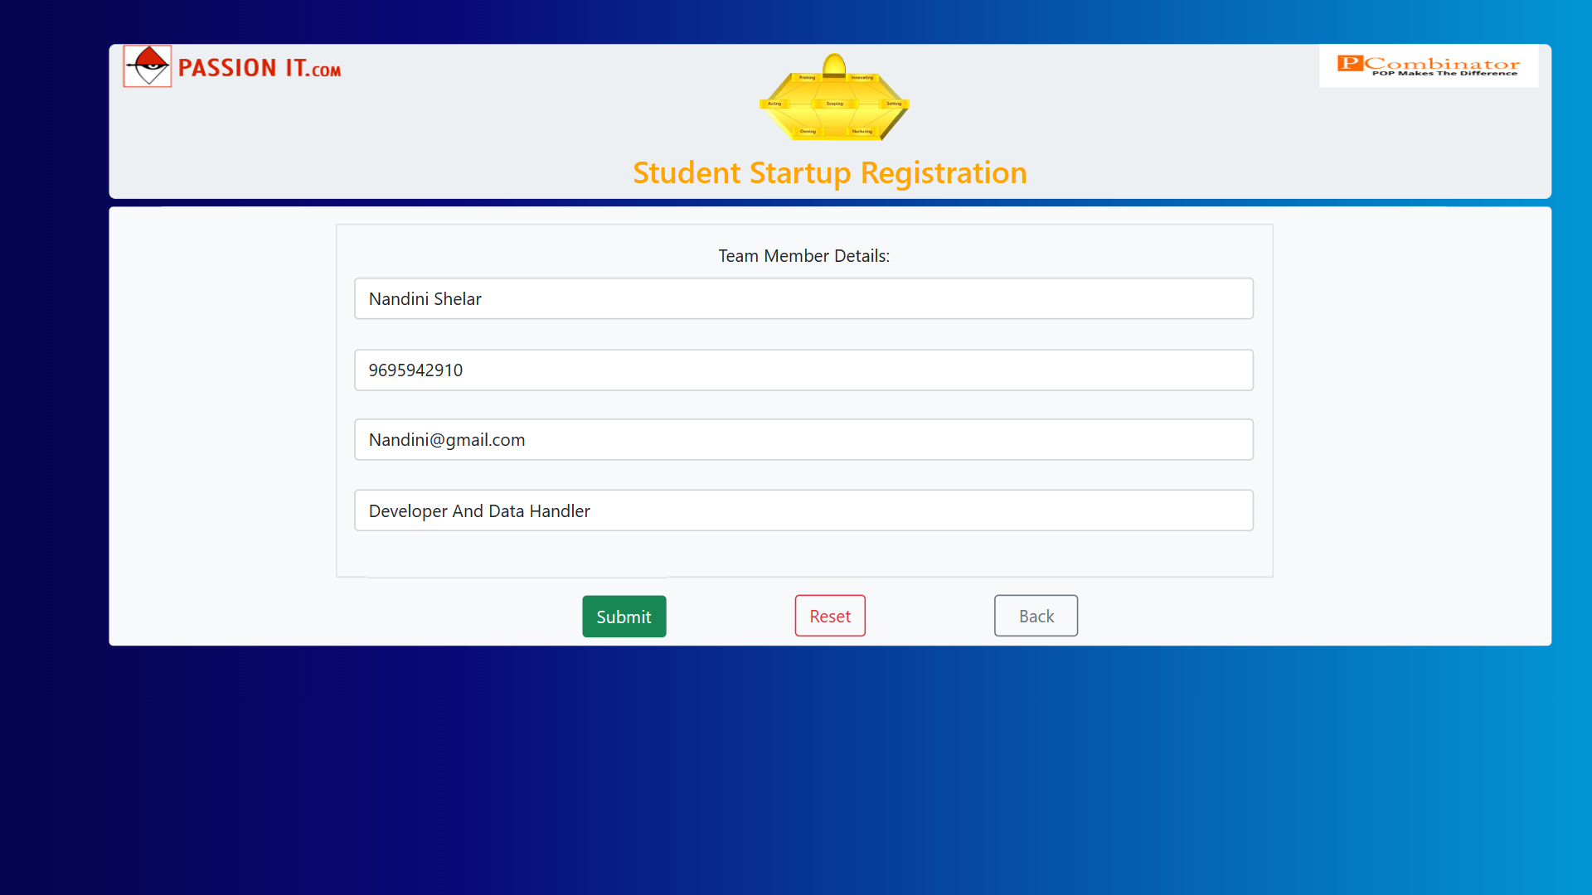

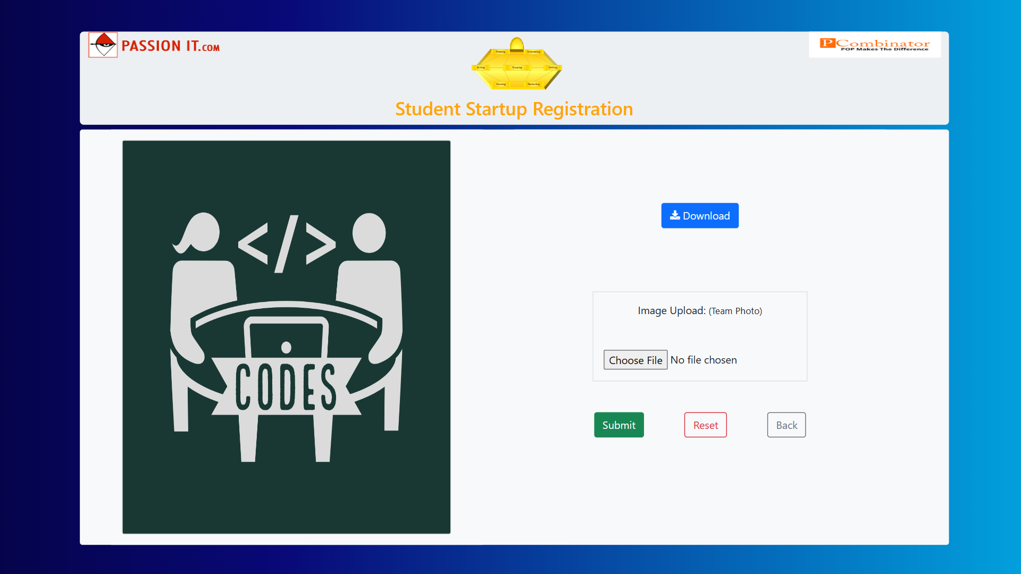

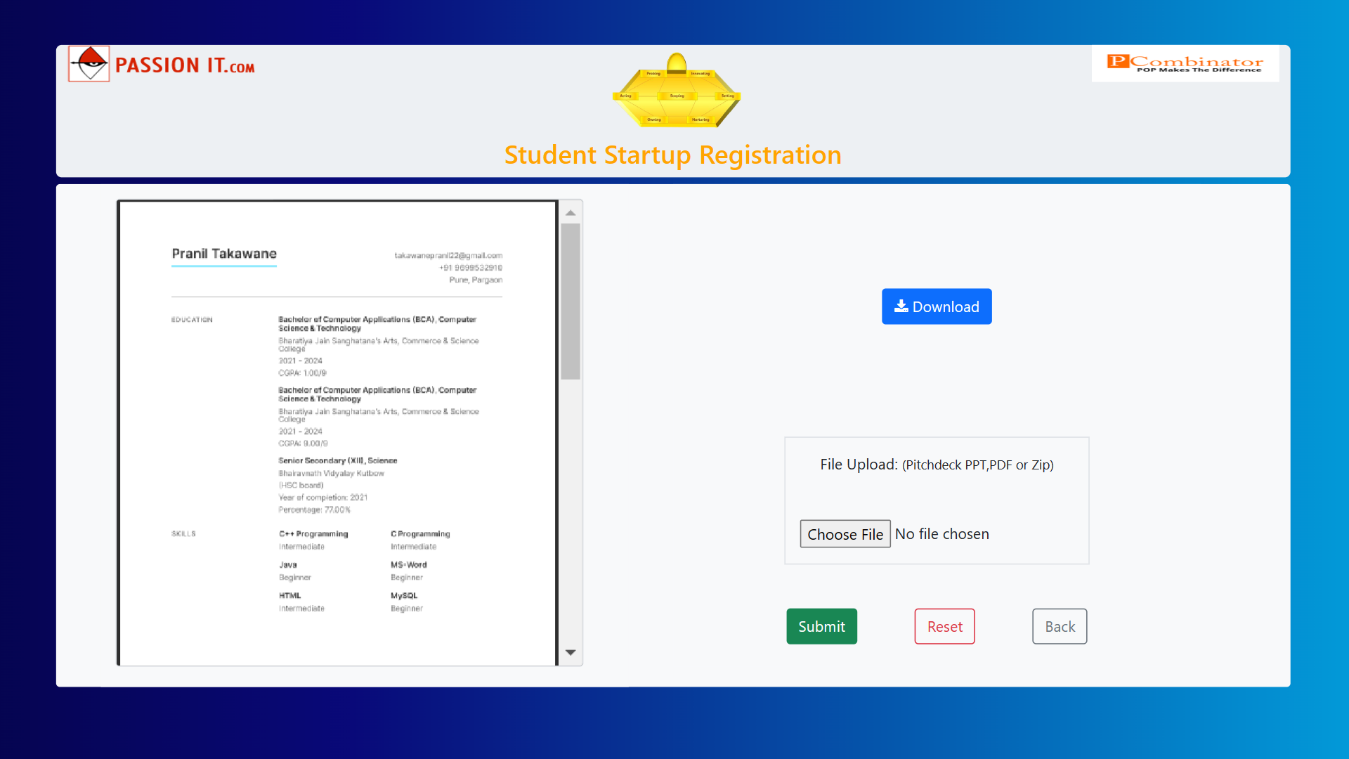

5.4 Add More Team Members

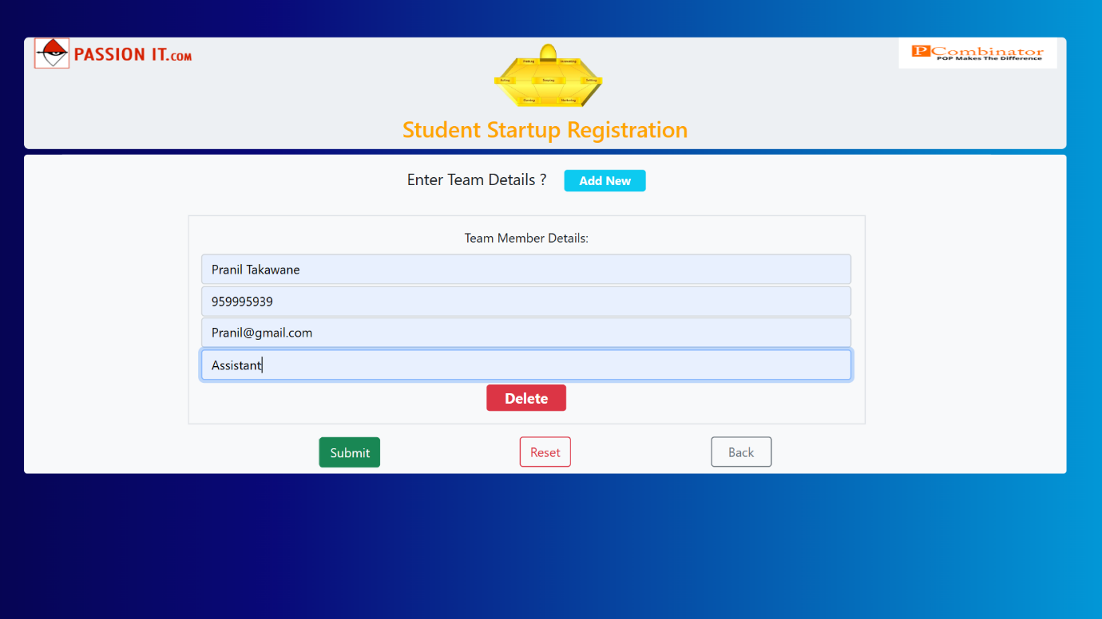

5.4 Database

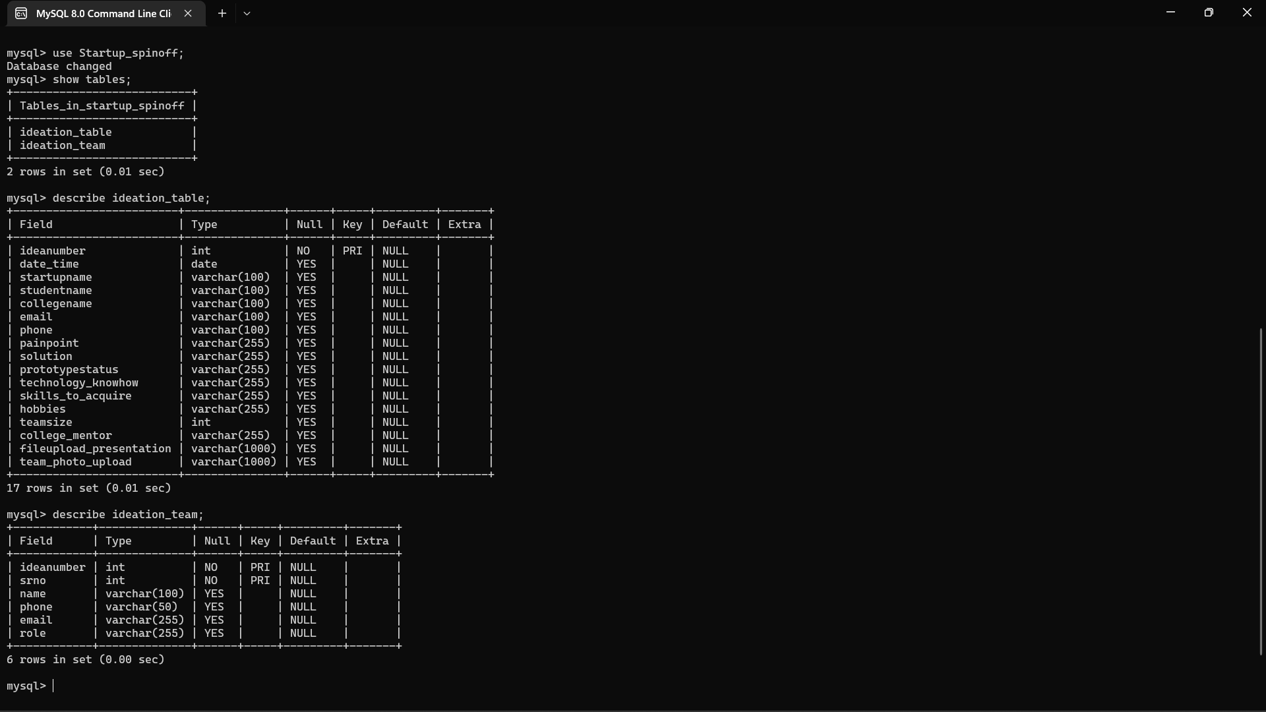

* Digramatic View Of Project

